**Project Name- Tata CLiQ**

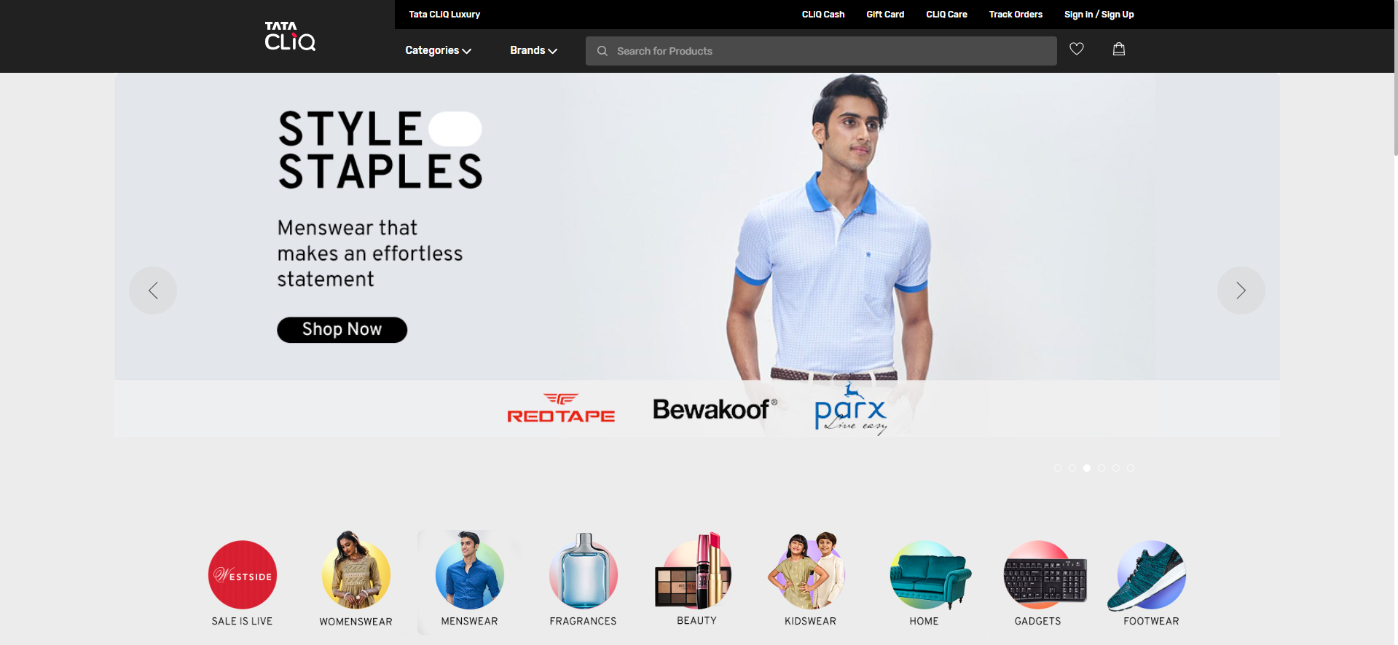

**Website Overview:**

Tata Cliq is an Indian e-commerce Website based in India. It is owned by Tata Digital Limited, of Tata Group.

Tata CLiQ operates in categories such as **Electronics, Fashion, Footwear, and Accessories.** Tata Group's E-commerce platform Tata CLiQ also launched a premium and luxury fashion and lifestyle destination, Tata CLiQ Luxury and It has housed a wide range of apparel and accessories for men and women by luxury and bridge-to-luxury brands.

**Type of website:** e-Commerce**,** Fashion**,** Marketplace.

**Home Page:**

* Logo
* Navigation Bar
* Cart
* Orders
* Sing In/Sing Up
* Icons
* Search Bar
* Sliders (Images)
* Best Deals (Images)
* Featured (Images)
* Trending (Images)
* Category logo
* Footer (copyright notice, link to a privacy policy, logo, contact information, social media icons)

**Main Page:**

**Filter**

* Category
* Brand
* Price
* Colour
* Discount
* Rating
* Size
* Type
* Short by
* Image of the chosen Product with Details Like- Brand, Product Name, Discount of Percentage (%)
* On Click the Image (Multiple Images of the Product Will Appear from Different Angels)

**Listing Page:**

**Filters:**

* Department
* Category
* Product Type
* Brand
* Price
* Products